**Load document**



Calvin Hong – 431518

Semester 6 - RB03

# Introduction

Load and performance testing is important, since it simulates real user scenarios. By doing these tests, performance can be evaluated with real data. Bottlenecks can be identified before they are actually hit in production. In this document, the testing of the game platform will be documented.

For generating load and monitoring the details, Apache JMeter is used. JMeter is an Apache project that can be used as a load testing tool for analyzing and measuring the performance of a variety of services.

First of all, JMeter was downloaded and started up. In the GUI, tests can be written and the intensity can be configured. Example view:

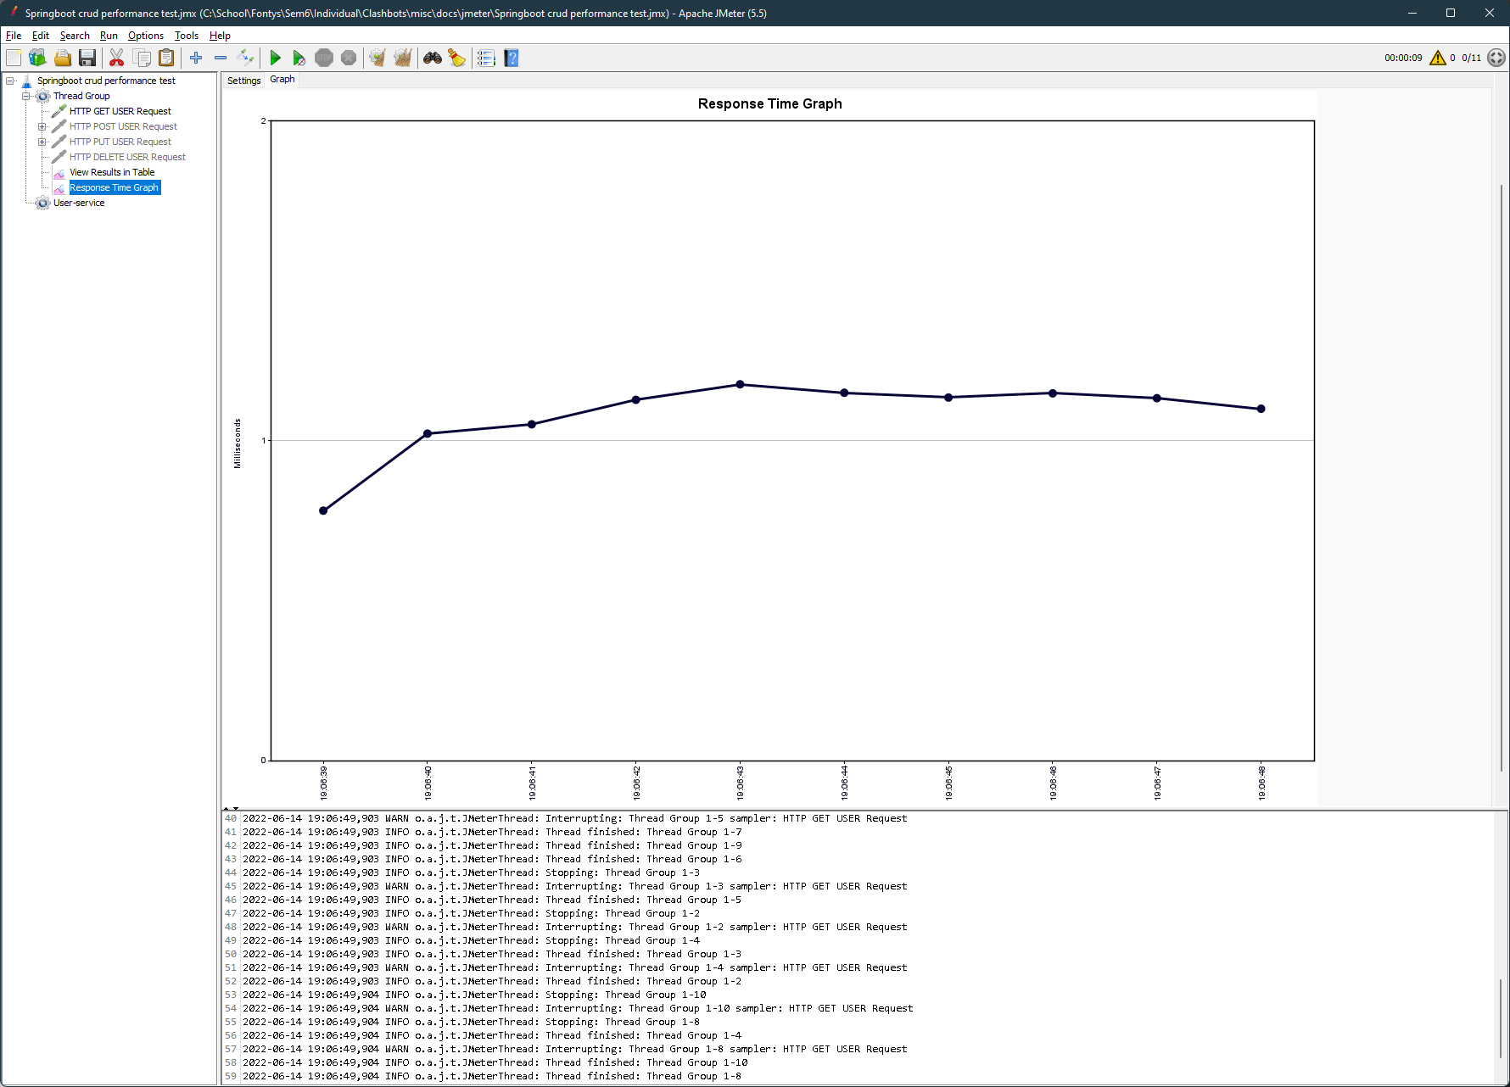

# Tests

For these tests, we have to pick an amount/number to run. In the estimated load document, we picked the population of Japan, since the blockchain is said to come from this country. However, since this document will only focus on the game service, we will pick a more realistic number. This number will be based of an existing game. One of the more popular RPG games with multiplayer functionality is the game: **Elden Ring**. This game has, according to activeplayer.io, around 3 million active players in the last 30 days. This is around 100.000 players per day, or about 70 per minute

## Get all Games

### Request information

|  |  |
| --- | --- |
| **Protocol** | **http** |
| **Server name** | **Localhost** |
| **Port** | **9191** |
| **HTTP Request** | **GET** |
| **Path** | **/games/** |
| **Body data** | **-** |

### Thread properties

|  |  |
| --- | --- |
| **Number of threads** | **100** |
| **Ramp up period (seconds)** | **5** |
| **Loop count** | **50** |

### Results

|  |  |
| --- | --- |
| **Samples** | **5000** |
| **Average** | **429** |
| **Min** | **48** |
| **Max** | **946** |
| **Error %** | **0.00%** |
| **Throughput** | **189.7/s** |

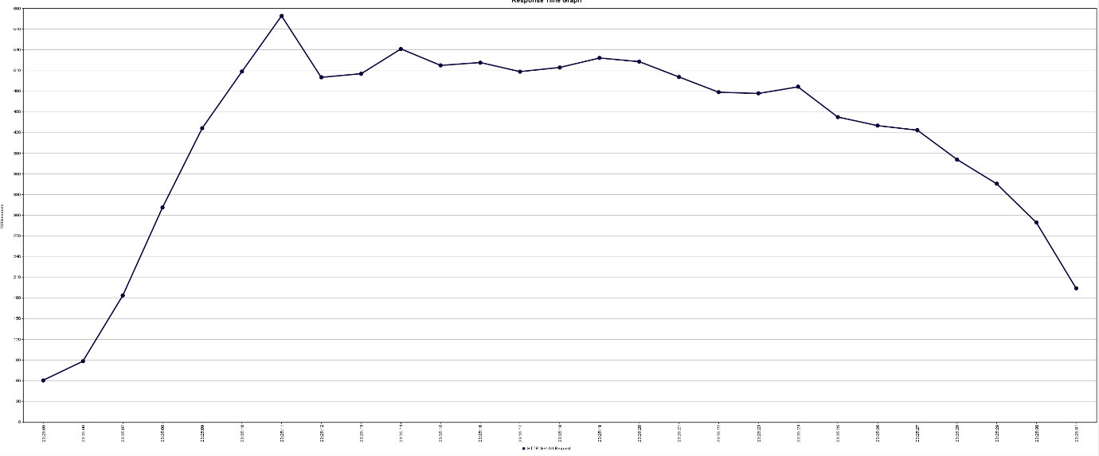

## Get Game by Status

### Request information

|  |  |
| --- | --- |
| **Protocol** | **http** |
| **Server name** | **Localhost** |
| **Port** | **9191** |
| **HTTP Request** | **GET** |
| **Path** | **/games/status/FINISHED** |
| **Body data** | **-** |

### Thread properties

|  |  |
| --- | --- |
| **Number of threads** | **100** |
| **Ramp up period (seconds)** | **5** |
| **Loop count** | **50** |

### Results

|  |  |
| --- | --- |
| **Samples** | **5000** |
| **Average** | **47** |
| **Min** | **12** |
| **Max** | **128** |
| **Error %** | **0.00%** |
| **Throughput** | **701.6/s** |

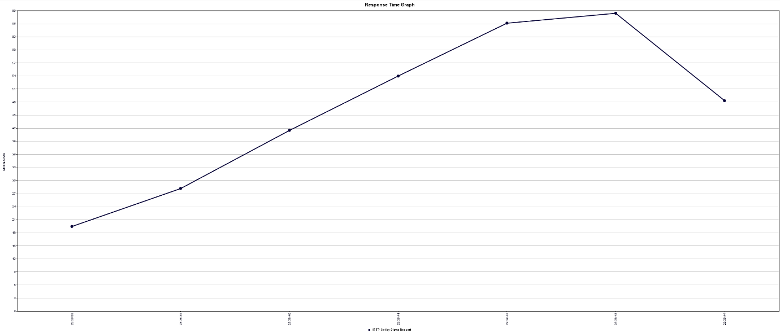

## Get Game by ID

### Request information

|  |  |
| --- | --- |
| **Protocol** | **http** |
| **Server name** | **Localhost** |
| **Port** | **9191** |
| **HTTP Request** | **GET** |
| **Path** | **/games/fee6d002-473d-4a0d-855d-b9020f01e2c0** |
| **Body data** | **-** |

### Thread properties

|  |  |
| --- | --- |
| **Number of threads** | **100** |
| **Ramp up period (seconds)** | **5** |
| **Loop count** | **50** |

### Results

|  |  |
| --- | --- |
| **Samples** | **5000** |
| **Average** | **419** |
| **Min** | **48** |
| **Max** | **1059** |
| **Error %** | **0.00%** |
| **Throughput** | **193.2/s** |

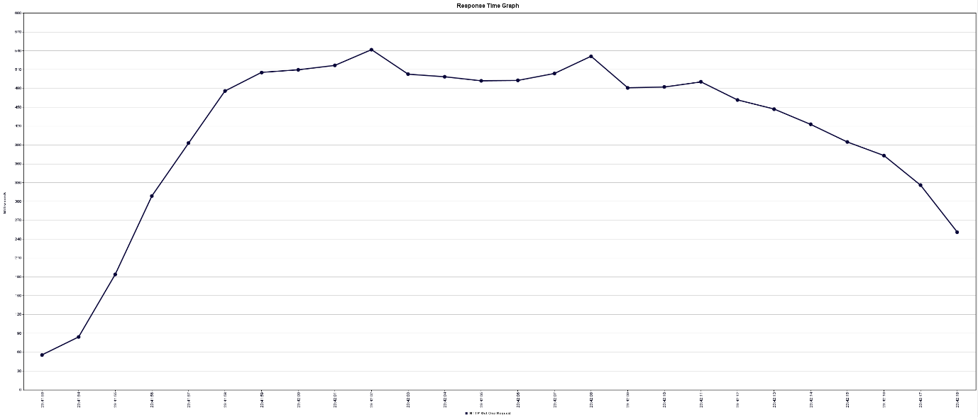

## Start Game

### Request information

|  |  |
| --- | --- |
| **Protocol** | **http** |
| **Server name** | **Localhost** |
| **Port** | **9191** |
| **HTTP Request** | **POST** |
| **Path** | **/games/start** |
| **Body data** | {  "userAddress":"0xf5b58aa66258166b47e7dc9e76053129d345efa7",  "userSide":"HUMANS" } |

### Thread properties

|  |  |
| --- | --- |
| **Number of threads** | **100** |
| **Ramp up period (seconds)** | **5** |
| **Loop count** | **50** |

### Results

|  |  |
| --- | --- |
| **Samples** | **5000** |
| **Average** | **591** |
| **Min** | **61** |
| **Max** | **1257** |
| **Error %** | **0.00%** |
| **Throughput** | **143.3/s** |

